**Website A/B Test**

**Project Objective**

**The goal of this analysis is to evaluate whether the new treatment version of the website leads to a statistically significant improvement in conversion rates compared to the current control version, based on data collected from an A/B experiment and discover some facts about the dataset.**

**Data Summary**

* **Total observations: 69,889 users**
* **Control group: 35211**
* **Treatment group: 34678**
* **A conversion is defined as whether a user made a purchase on the website or not.**

**Methodology**

**We applied multiple statistical methods to analyze the experiment results:**

* **Two-Proportion Z-Test:  
  Compared the conversion rates between the control and treatment groups to detect any statistically significant difference.**
* **Logistic Regression:  
  Modeled the probability of conversion based on group assignment, using all individual user data, to estimate the effect size and statistical significance.**

**Results**

| **Group** | **Conversion Rate** |
| --- | --- |
| **Control** | **10.5%** |
| **Treatment** | **15.5%** |
| **Absolute Difference** | **~5%** |

**69.9% of website visitors are from US.**

**We also found out that US has highest conversion rate in this dataset.**

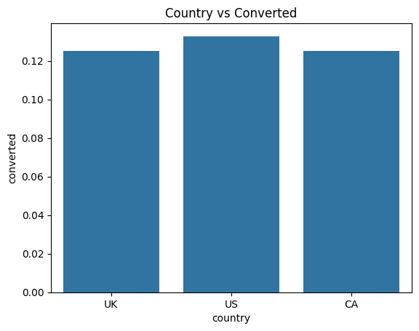

**Two-Proportion Z-Test**

**z-statistic: -0.094**

**P-value: 0.92**

**Conclusion: No statistically significant difference detected at 5% significance level.**

**Logistic Regression**

**Coefficient for treatment: 0.4467**

**P-value: < 0.001**

**Odds Ratio: e0.4467 = 1.56**

**Conclusion: The odds of conversion increase by approximately 56% for users who see the treatment page compared to the control page. The treatment group has a statistically significant positive effect on conversion odds.**

**Business Interpretation**

* **While the absolute increase in conversion rate is relatively small (about 0.4%), the large sample size allows us to detect that this difference is statistically significant using logistic regression.**
* **For a business with high traffic volume, even small improvements in conversion rates can accumulate into meaningful revenue increases over time.**
* **If implementation costs for the treatment page are low, switching to the treatment version is likely justified.**
* **Further A/B testing on specific user segments or longer-term experiments could provide additional insights.**

**Recommendation**

**Based on the analysis, I recommend considering deployment of the treatment page, as it shows statistically significant improvement in conversion. However, if the business requires stronger evidence of large financial impact, further experimentation may be advisable.**